**Que – 1.** Find the number of orders that are small, medium or large order values (small : 0-5$, medium : 5-10$, large : 10+)

**Ans – 1.**

with t as

(select basket_id,sum(quantity*sales_value) as total_price,

case when sum(quantity*sales_value) <= 5

then "Small"

when sum(quantity*sales_value) <= 10

then "Medium"

else "Large"

end as size_of_order

from fluid-arc-394607.dunnhumby.transaction_data

group by 1)

select size_of_order,count(*) from t

group by 1

**Que – 2.** Find top 3 stores with the highest foot traffic for each week (Foot traffic : number of customer transacting)

**Ans – 2.**

with t1 as

(select store_id,week_no,count(household_key)as footfall from fluid-arc-394607.dunnhumby.transaction_data

group by 1,2),

t as

(select *,dense_rank()over(partition by week_no order by footfall desc) as ranker

from t1)

select week_no,store_id,footfall,ranker from t

where ranker<=3

order by week_no

**Que – 3.** Create a basic customer profiling with first, last visit, number of visits, average money spent per visit and total money spent order by highest avg money.

**Ans – 3.**

select household_key,

min(week_no) as first_visit,

max(week_no) as last_visit,

count(distinct basket_id) as total_visit,

round(sum(quantity*sales_value),2) as total_amount,

round(sum(quantity*sales_value)/count(basket_id),2) as avg_money

from fluid-arc-394607.dunnhumby.transaction_data

group by 1

-------------------------------------------------------------------------

**OR**

with base as

------------------------------------------------------------------------------------

(select household_key,

min(week_no) as first_visit,

max(week_no) as last_visit,

count(distinct week_no) as total_visit,

round(sum(quantity*sales_value),2) as total_amount

from fluid-arc-394607.dunnhumby.transaction_data

group by 1),

------------------------------------------------------------------------------------

base1 as

(select household_key,round(sum(total_spent)/count(household_key),2)as avg_spent from

------------------------------------------------------------------------------------

(select household_key,basket_id,sum(quantity*sales_value) as total_spent

from fluid-arc-394607.dunnhumby.transaction_data

group by 1,2)

------------------------------------------------------------------------------------

group by 1)

------------------------------------------------------------------------------------

select b1.*,b2.avg_spent

from base as b1

left join base1 as b2

on b1.household_key=b2.household_key

order by b1.household_key

**Que – 4.** Do a single customer analysis selecting most spending customer for whom we have demographic information(because not all customers in transaction data are present in demographic table)(show the demographic as well as profiling data)

**Ans – 4.**

with base as

(select household_key,

min(week_no) as first_visit,

max(week_no) as last_visit,

count(distinct basket_id) as total_visit,

round(sum(quantity*sales_value),2) as total_amount,

round(sum(quantity*sales_value)/count(basket_id),2) as avg_money

from fluid-arc-394607.dunnhumby.transaction_data

group by 1)

select * from fluid-arc-394607.dunnhumby.hh_demographic as a

join base as b

on a.household_key=b.household_key

order by b.total_amount desc

limit 1

**Que – 5.** Find products(product table : SUB_COMMODITY_DESC) which are most frequently bought together.

**Ans – 5.**

with base as

(select basket_id,p.sub_commodity_desc as product

from fluid-arc-394607.dunnhumby.transaction_data as t

inner join fluid-arc-394607.dunnhumby.product as p

on t.product_id=p.product_id)

select a.product,b.product,count(distinct a.basket_id)as popularity

from base a

inner join base b

on a.basket_id=b.basket_id and a.product<b.product

group by 1,2

order by count(distinct a.basket_id)desc

**Que – 6.** Find out on which weeks does each household shop and find their cumulative spending over time(sum of all previous)(uses sum over partition)

**Ans – 6.**

with base as

(select household_key,week_no,round(sum(quantity*sales_value),2) as spending

from fluid-arc-394607.dunnhumby.transaction_data as t

group by 1,2)

select *,round(sum(spending)over(partition by household_key order by week_no),2) as running_sum

from base

**Que – 7.** Find the weekly change in Revenue Per Account (RPA) (spending by each customer compared to last week)(use lag function)

**Ans – 7.**

with base as

(select household_key,week_no,round(sum(quantity*sales_value),2) as spending

from fluid-arc-394607.dunnhumby.transaction_data as t

group by 1,2),

base2 as

(select *,lag(spending,1)over(partition by household_key order by week_no) as prev_week_rev,

case when lag(spending,1)over(partition by household_key order by week_no)=0 then spending

else lag(spending,1)over(partition by household_key order by week_no)

end as final_prev_week_rev

from base)

select *,round((spending-final_prev_week_rev)/final_prev_week_rev*100,2) as per_change

from base2

**Que – 8.** Find number of returning customers and percent of returning customers for all week.

**Ans – 8.**

with base as

(select household_key, min(week_no)over(partition by household_key)as min_week,week_no

from fluid-arc-394607.dunnhumby.transaction_data),

base_2 as

(select *, case when week_no>min_week then "returning" else "new_customer" end as label

from base),

base_3 as

(select week_no,label,count(distinct household_key) as count_cust from base_2

group by 1,2

order by 1 asc),

base_4 as

(select *,sum(count_cust)over(partition by week_no)as total_cust

from base_3)

select week_no,round((count_cust/total_cust)*100,2) as returning_percentage

from base_4

where label="returning"

order by week_no

OR

-----------------------------------------------------------------------------------with base as

(select household_key,week_no

from fluid-arc-394607.dunnhumby.transaction_data as t

group by 1,2),

base2 as

(select *,lag(week_no,1)over(partition by household_key order by week_no) as prev_week_no

from base),

base3 as

(select count(*)over(partition by week_no)

from base2

order by week_no)

select week_no,count(diff)/count(prev_week_no)*100 as percentage_ret_customer

from base3

where prev_week_no is not null

group by 1

-- as total_cutomer_returning

--where diff=1

**Que – 9.** Quarterly analysis: sales comparison: total sale amount (create a new quarter column case where 12 weeks/3 months)-1 quarter)

**Ans – 9.**

with base as

(select *,ceil(week_no/12)as quarter

from fluid-arc-394607.dunnhumby.transaction_data)

select quarter,round(sum(sales_value*quantity),2)as total_sales

from base

group by 1

**Que – 10.** How are the sales for individual stores changing over the quarters.

**Ans – 10.**

with base as

(select *,ceil(week_no/12)as quarter

from fluid-arc-394607.dunnhumby.transaction_data)

select store_id,quarter,round(sum(sales_value*quantity),2)as total_sales

from base

group by 1,2

order by store_id

**Que – 11.** Customer churn analysis for each quarter (churned customers : that never shop after that particular quarter)

**Ans – 11.**

with base as

(select household_key,ceil(week_no/12)as quarter

from fluid-arc-394607.dunnhumby.transaction_data

group by 1,2)

select x.quarter,count(x.household_key)as customer_churned

from base as x

left join base as y

on x.household_key=y.household_key and x.quarter<y.quarter

where y.quarter is null

group by 1

order by x.quarter

**OR**

with base as

(select ceil(week_no/12)as quarter,household_key

from fluid-arc-394607.dunnhumby.transaction_data

group by 1,2)

select x.quarter,count(distinct x.household_key)as customer_churned

from base as x

full outer join base as y

on x.household_key=y.household_key and x.quarter<y.quarter

where y.household_key is null

group by 1

order by 1 asc

Here, we can’t use self join because Null will not going to connect with Null.

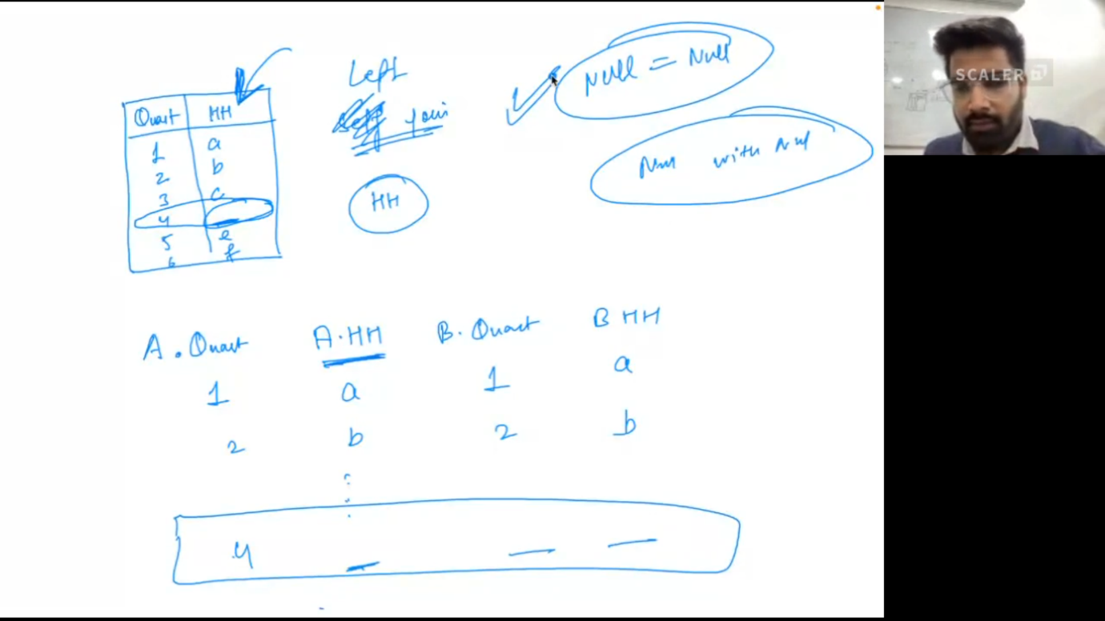

**Que – 12.** Find the retained customers for each quarter (retained : Households who were there in previous quarters and are there in the current quarter)

**Ans – 12.**

with base0 as

(select *,ceil(week_no/12)as quarter

from fluid-arc-394607.dunnhumby.transaction_data),

base as

(select household_key, min(quarter)over(partition by household_key)as min_quarter,quarter

from base0),

base_2 as

(select *, case when quarter>min_quarter then "returning" else "new_customer" end as label

from base),

base_3 as

(select quarter,label,count(distinct household_key) as count_cust from base_2

group by 1,2

order by 1 asc),

base_4 as

(select *,sum(count_cust)over(partition by cast(quarter as int))as total_cust

from base_3)

select quarter,round((count_cust/total_cust)*100,2) as returning_percentage

from base_4

where label="returning"

order by quarter

**Que – 13.** Calculate Customer lifetime value (CLV) for different age group

Average purchase value – the value of all customer purchases over a particular time frame, divided by the number of purchases in that period

Average purchase frequency – divide the number of purchases in that same time period by the number of individual customers who made a transaction over the same period

Customer value – the average purchase frequency multiplied by the average purchase value

Average customer lifespan – the average length of time a customer continues buying from you

CLV = customer value X average customer lifespan

**Ans – 13.**

with base as

(select household_key, max(week_no)-min(week_no) as cust_duration

from fluid-arc-394607.dunnhumby.transaction_data

group by 1),

base_2 as

(select AGE_DESC, sum(a.cust_duration)/count(*)as avg_cust_lifespan,count(distinct b.basket_id)/count(distinct a.household_key)as aver_pur_freq,sum(b.quantity*b.sales_value)/count(distinct b.basket_id)as avg_pur_value

from base a

right join fluid-arc-394607.dunnhumby.transaction_data b

on a.household_key=b.household_key

left join fluid-arc-394607.dunnhumby.hh_demographic c

on a.household_key=c.household_key

group by 1)

select *,aver_pur_freq*avg_pur_value*avg_cust_lifespan as CLV from base_2